Toasted Muesli 14
Oats & nuts, seasonal fruits & honey sesame panna cotta

Dench Baker’s Toast 8
Sourdough/Wholegrain, with butter & your choice of jam, vegemite, or honey
Gluten Free +3

Fruit Toast 10
Dench Baker’s spiced fruit loaf with blueberry butter

Pancakes 18
Banana, choc chips, salted caramel & macadamia nuts

Porridge 16
Semolina porridge, apple, rhubarb, cinnamon & walnut praline

Free Range Eggs 11
Two eggs poached/scrambled/fried, on sourdough toast

Breakfast Burger 14
Bacon, egg, hash brown, cheese & relish

Smashed Avo 18
Two eggs, Meredith goat’s cheese, cherry tomatoes, beetroot relish, avocado, on wholegrain toast

Benny 19
Two eggs, pork belly, potato rosti & hollandaise

Soup of the Day 13
With herb and parmesan damper
Roast Pumpkin 18
Roasted pumpkin, kale, spinach, poached egg, dill hollandaise, on beetroot sourdough

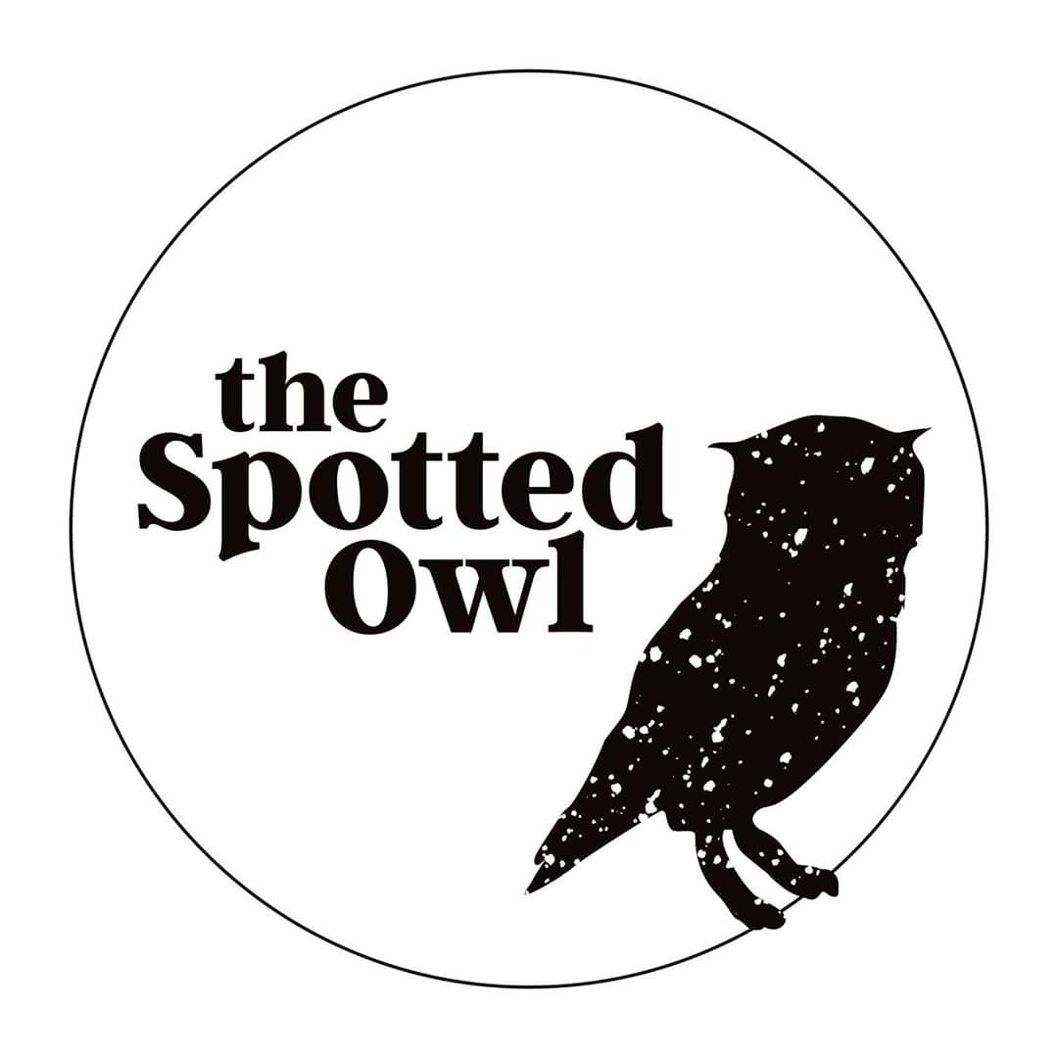
Roast Chicken 22
Oven roasted chicken, winter vegetables, leek and chicken jus

Salmon Croquettes 21
Salmon, potatoes, capers, gherkins, avocado crème, leaves & citrus

Fritters 19
Corn, zucchini, chickpeas, chimichurri, radish & cress

Burrito Bowl 19
Brown rice, black beans, capsicum, avocado, charred corn, kale, jalapeno sour cream & corn tortilla

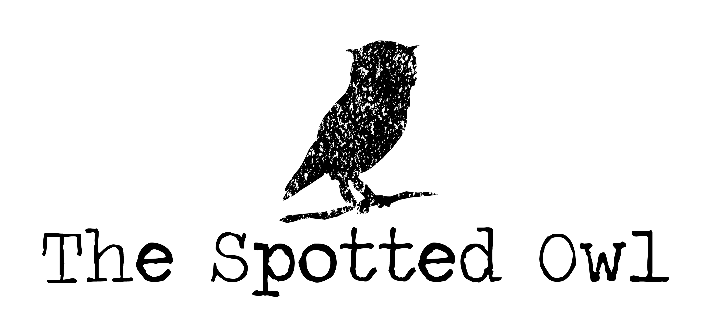
Beef Burger 21
Beef patty, lettuce, tomato, cheese, pickles, aioli, served with chips - Add egg $2 - Add bacon $2

Chips S 5 / L 8
With aioli or tomato sauce

Little people (Under 12)
Single poached egg on toast 6
Toast with butter & jam/vegemite/honey 6
Pancakes, maple syrup, ice cream, wafer 7.5
Ham & cheese melt 7.5
Nuggets & chips 9

Sides
Extra toast 2.5
Extra egg/relish/hollandaise 3
Spinach/tomato/mushroom/hash brown 4
Goats cheese/haloumi/avocado 5
Bacon/smoked salmon/chorizo 5

*All items on menu are available for takeaway*

Filtered sparkling water 2
750ml

Organic Juice 5.5
Orange, cranberry, apple & coconut water

Hepburn Springs mineral water 5.5
Ginger beer, blood orange, pink grapefruit, orange & passionfruit,
sparkling water

Remedy Kombucha 6
Ginger & lemon, raspberry lemonade, peach, cherry & plum,
blood orange (sugar free)

Soft drink 4.5
Coke, diet coke, coke zero, lemonade, tonic water,
lemon lime & bitters

Milkshakes 6.5
Banana, caramel, coconut, chocolate, choc mint,
cookies & cream, Jaffa, lime, strawberry, vanilla
Kids flavoured milk 4

Iced latte ice, milk, coffee S 4 / L 5
Iced coffee ice cream, milk, coffee 6.5
Iced chocolate ice cream, milk, chocolate 6.5
Iced mocha ice cream, milk, coffee & choc 6.5

Wines by the glass
Sparkling - De Bortolli Prosecco (Vic)
White - Yalumba Pinot Grigio (S.A), Torres Vina Sol (Spain)
Red - Borsoa Grenache (Spain)

Beer & Cider
Asahi, Carlton Draught, Coopers Pale Ale, Coopers Sparkling Ale,
Corona, Little Creatures Pale Ale, Holgate Gatekeeper, Cascade Light,
Grape Tree Grape Cider, Somerby Apple Cider
Tea 4
English breakfast, earl grey, green, lemongrass & ginger,
peppermint, chamomile

Brewed chai latte 5.5
Soy milk, honey, cinnamon

Dirty chai 6
Soy milk, coffee, honey

Muddy chai 6
Soy milk, chocolate

Coffee S 4 / L 5 Variety of white & black coffee

Mocha S 4 / L 5
Coffee and chocolate with your choice of milk

Hot chocolate S 4 / L 5
Dark hot chocolate (Mork), sweet hot chocolate

Brewed bounty S 5 / L 6
Dark chocolate (Mork) & coconut milk

Matcha latte S 5 / L 6
Matcha (green tea), coconut milk & honey

Golden latte S 5 / L 6
Turmeric, cinnamon, almond milk & honey

+ Soy milk Bonsoy, Coconut milk Cocoquench 0.5
+ Almond milk Milk Lab 0.75
+ Syrup – caramel, hazelnut, white choc, vanilla 0.7

Cold Drip Coffee 5
Brewed and chilled single origin served with an orange wedge

